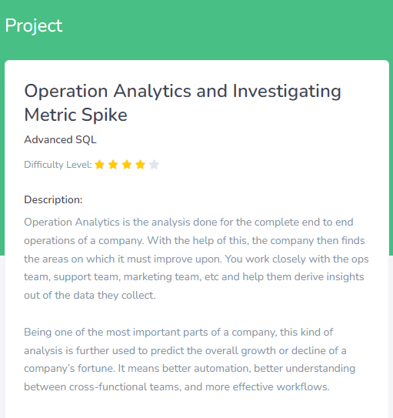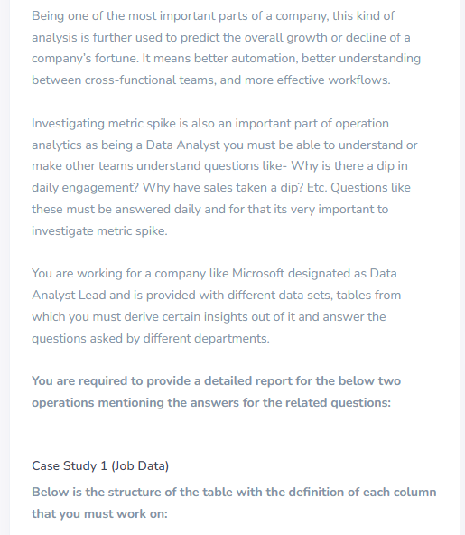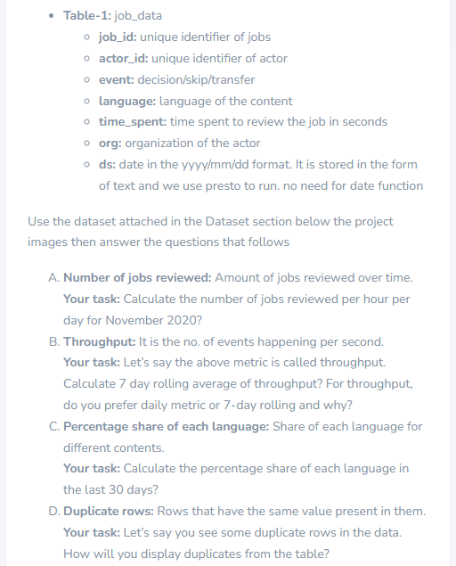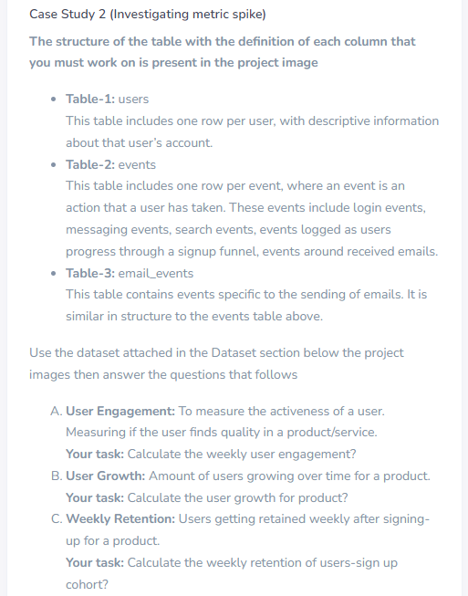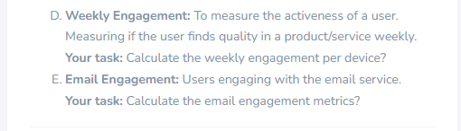

**Operation Analytics and Investigating Metric Spike**

**Case Study 1 (Job Data)**

**Table-1:**job_data

CREATE DATABASE investigating;

USE investigating;

CREATE TABLE job_data

(

ds DATE,

job_id INT NOT NULL,

actor_id INT NOT NULL,

event VARCHAR(15) NOT NULL,

language VARCHAR(15) NOT NULL,

time_spent INT NOT NULL,

org CHAR(2)

);

INSERT INTO job_data (ds, job_id, actor_id, event, language, time_spent, org)

VALUES ('2020-11-30',21, 1001, 'skip', 'English', 15, 'A'),

('2020-11-30', 22, 1006, 'transfer', 'Arabic', 25, 'B'),

('2020-11-29', 23, 1003, 'decision', 'Persian', 20, 'C'),

('2020-11-28', 23, 1005,'transfer', 'Persian', 22, 'D'),

('2020-11-28', 25, 1002, 'decision', 'Hindi', 11, 'B'),

('2020-11-27', 11, 1007, 'decision', 'French', 104, 'D'),

('2020-11-26', 23, 1004, 'skip', 'Persian', 56, 'A'),

('2020-11-25', 20, 1003, 'transfer', 'Italian', 45, 'C');

table job_data;

**A. Number of jobs reviewed:**

select ds,count(job_id) as job_spent_per_day, sum(time_spent)/3600 as job_spent_per_hour from job_data where ds >='2020-11-01' and ds <='2020-11-30' group by ds;

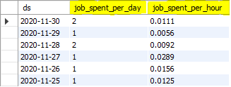

**B. Throughput:**

select job_id,ds,time_spent,avg(time_spent) over(order by ds rows between 6 preceding and current row) as ave from job_data order by ds;

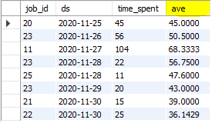

**I prefer both daily metric and 7-days rolling because daily metric gives daily calculation which is easy to calculate and 7-days rolling values gives extreme values. Both datas are needed and useful.**

**C. Percentage share of each language:**

select language,round(count(language)*100/8,2) as ave from job_data where ds >='2020-11-01' and ds <='2020-11-30' group by language;

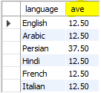

**D. Duplicate rows:**

SELECT job_id,count(*) as duplicate FROM job_data GROUP BY job_id HAVING duplicate > 1;



SELECT ds,count(*) as duplicate FROM job_data GROUP BY ds HAVING duplicate > 1;



SELECT event,count(*) as duplicate FROM job_data GROUP BY event HAVING duplicate > 1;

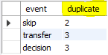

SELECT language,count(*) as duplicate FROM job_data GROUP BY language HAVING duplicate > 1;



SELECT actor_id,count(*) as duplicate FROM job_data GROUP BY actor_id HAVING duplicate > 1;



SELECT org,count(*) as duplicate FROM job_data GROUP BY org HAVING duplicate > 1;

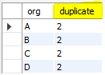

**Case Study 2 (Investigating metric spike)**

**Table-1:**users

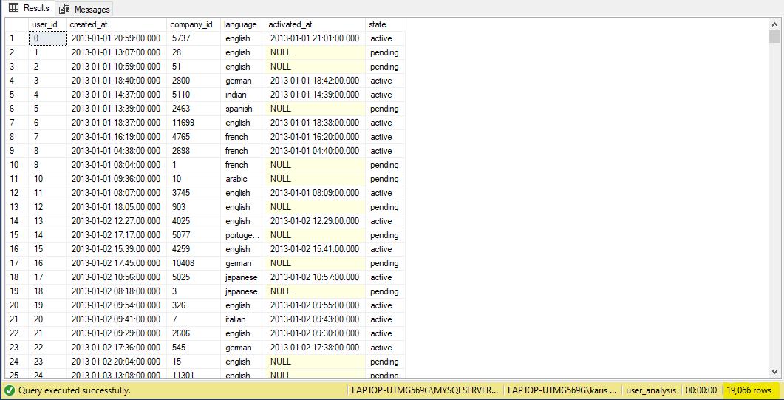

**Table-2:**events

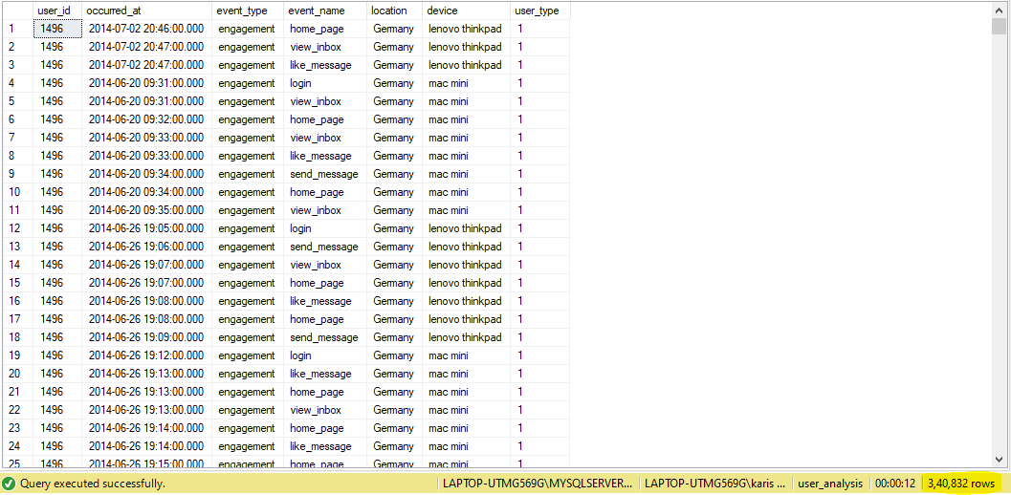

**Table-3:**email_events

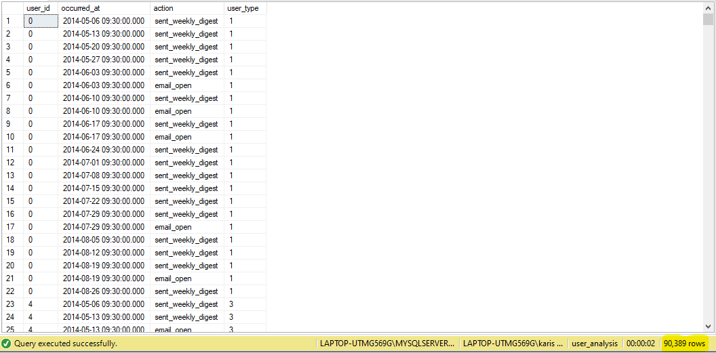

**A. User Engagement:**

select count(distinct user_id) as count_of_userid_per_week,

occurred_at,(DATEDIFF(week,occurred_at,getdate())) as count_of_engagement_per_week from events group by occurred_at order by count_of_engagement_per_week desc

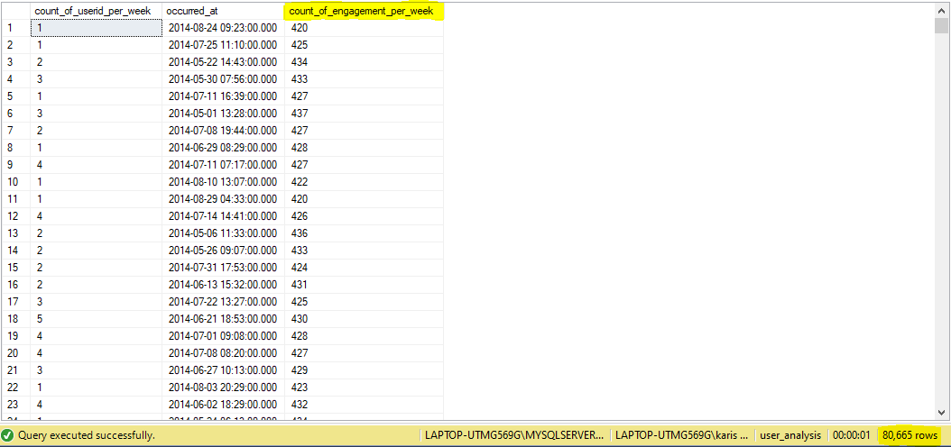

**B. User Growth:**

select device,count(device) as amount_of_user_growth_for_a_product from events group by device order by amount_of_user_growth_for_a_product desc

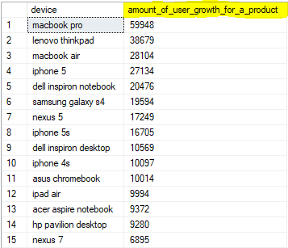

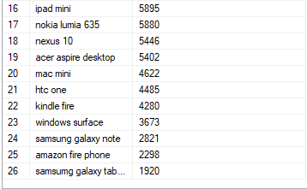

**C: Weekly Retention:**

select action,count(action) as weekly_retention_after_signup from email_events where action='sent_weekly_digest' group by action



**D. Weekly Engagement:**

select distinct device,

DATEDIFF(week,occurred_at,getdate()) as count_of_engagement_per_week from events

group by occurred_at,device order by count_of_engagement_per_week desc

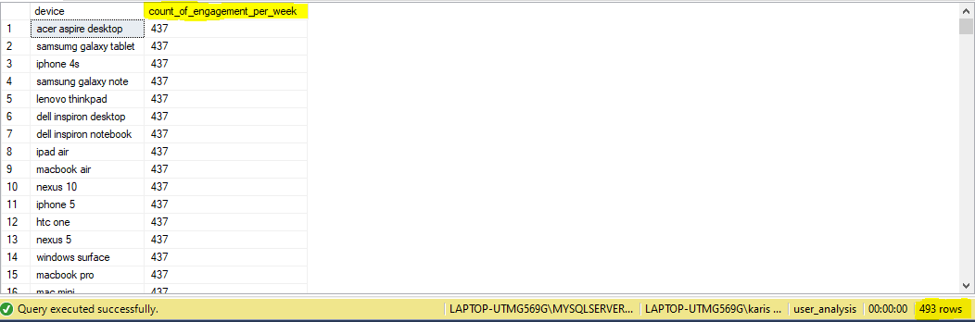

**E. Email Engagement:**

select count(distinct events.user_id) as email_engagement_metrics,events.event_type,email_events.action from events,email_events where event_type='engagement' and action='email_open' group by event_type,action

